**Year 12 Examination, 2018**

**Question/Answer Booklet**

**MATHEMATICS SPECIALIST**

**Section Two: Calculator-assumed**

Student Name/Number: ______________________________________________

Teacher Name: ______________________________________________

**Time allowed for this section**

Reading time before commencing work: ten minutes

Working time for this section: one hundred minutes

**Materials required/recommended for this section**

**To be provided by the supervisor:** This Question/Answer Booklet

Formula Sheet (retained from Section One)

**To be provided by the candidate:**

Standard items: pens (blue/black preferred), pencils (including coloured), sharpener, correction fluid/tape, eraser, ruler, highlighters

Special items: drawing instruments, templates, notes on two unfolded sheets of A4 paper, and up to three calculators approved for use in the WACE examinations

**Important note to candidates**

No other items may be taken into the examination room. It is **your** responsibility to ensure that you do not have any unauthorised notes or other items of a non-personal nature in the examination room. If you have any unauthorised material with you, hand it to the supervisor **before** reading any further.

**Structure of this paper**

|  |  |  |  |  |  |
| --- | --- | --- | --- | --- | --- |
| Section | Number of questions available | Number of questions to be answered | Working time (minutes) | Marks available | Percentage of exam |
| Section One: Calculator-free | 7 | 7 | 50 | 50 | 35 |
| Section Two: Calculator-assumed | 11 | 11 | 100 | 100 | 65 |
|  | | | | | 100 |

**Instructions to candidates**

1. The rules for the conduct of School exams are detailed in the *_______________________________________School/College assessment policy*. Sitting this examination implies that you agree to abide by these rules.
2. Write your answers in this Question/Answer Booklet.

3. You must be careful to confine your responses to the specific questions asked and to follow any instructions that are specific to a particular question.

1. Spare pages are included at the end of this booklet. They can be used for planning your responses and/or as additional space if required to continue an answer.
   * Planning: If you use the spare pages for planning, indicate this clearly at the top of the page.
   * Continuing an answer: If you need to use the space to continue an answer, indicate in the original answer space where the answer is continued, i.e. give the page number. Fill in the number of the question that you are continuing to answer at the top of the page.
2. **Show all working clearly.** Your working should be in sufficient detail to allow your answers to be checked readily and for marks to be awarded for reasoning. Incorrect answers given without supporting reasoning cannot be allocated any marks. For any question or part question worth more than two marks, valid working or justification is required to receive full marks. If you repeat any question, ensure that you cancel the answer you do not wish to have marked.
3. It is recommended that you **do not use pencil**, except in diagrams.
4. The Formula Sheet is **not** to be handed in with your Question/Answer Booklet.

**Section Two: Calculator-assumed 65% (100 Marks)**

This section has **11** questions. Answer **all** questions. Write your answers in the spaces provided.

Spare pages are included at the end of this booklet. They can be used for planning your responses and/or as additional space if required to continue an answer.

* Planning: If you use the spare pages for planning, indicate this clearly at the top of the page.
* Continuing an answer: If you need to use the space to continue an answer, indicate in the original answer space where the answer is continued, i.e. give the page number. Fill in the number of the question that you are continuing to answer at the top of the page.

Suggested working time: 100 minutes.

**Question 8 (5 marks)**

By considering the possibilities that  or  separately, solve the equation





.

**Question 9 (6 marks)**

The polynomial

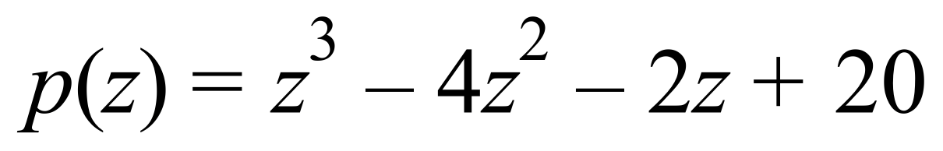

has one real factor and two complex conjugate factors.

1. Determine the real factor by trial and error or by sketching a graph, and verify your answer using the factor theorem. (3 marks)

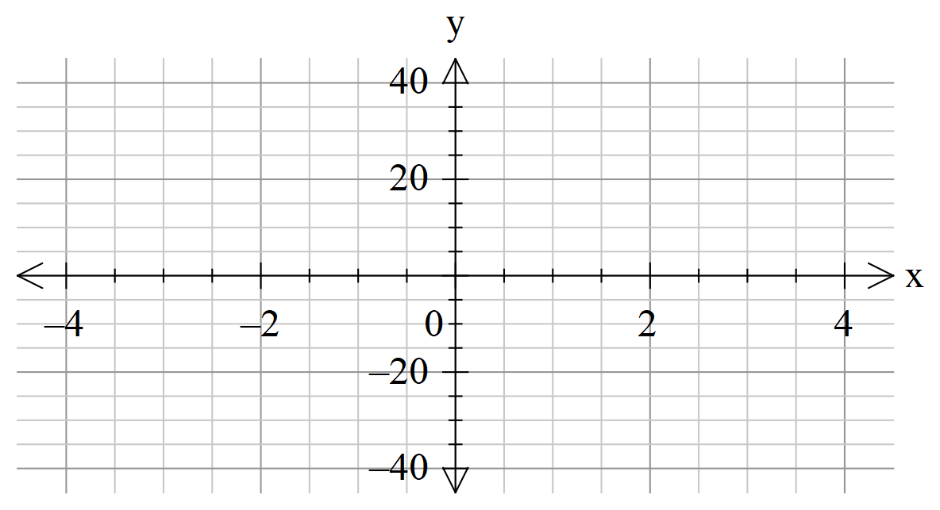

1. Hence, or otherwise, determine the complex conjugate factors. (3 marks)

**Question 10 (10 marks)**

A cannon ball is projected from the ground with an initial speed of at an angle of  (radians) to the horizontal.

Assume that the only force acting on the particle is the gravitational force and that acceleration due to gravity is.

If and are unit vectors in the horizontal and upwards vertical directions respectively,

(a) state the initial velocity vector, , of the cannon ball. (2 marks)

(b) determine the velocity vector , of the cannon ball at any time . (2 marks)

1. Determine the maximum height and the horizontal range of the cannon ball. (6 marks)

**Question 11 (11 marks)**

The complex numbers  and  are given by  and and  .

The three points  together with the origin O form the vertices of a parallelogram *P* in the complex plane.

1. Show that *P* is a rhombus by determining exactly the lengths of its sides. (2 marks)
2. Calculate, correct to 2 decimal places, the size (in radians) of the angle between the sides of P that meet at O. (3 marks)
3. Show that . (2 marks)
4. Use part (c) to determine the ratio of the lengths of the diagonals and the angle between them. (4 marks)

**Question 12 (9 marks)**

The function  is defined to be

.

1. Show that the function is defined for all real values of. (3 marks)
2. If two real values  and  are such that, how are  and  related?

(3 marks)

1. Is  a one-to-one function? Justify your answer. (3 marks)

**Question 13 (6 marks)**

Determine exactly the real and imaginary parts of all solutions of the equation

 .

**Question 14 (9 marks)**

1. If  determine the inverse function by restricting the domain in a suitable manner. (3 marks)

1. State the domain and the range of this inverse function. (2 marks)
2. Sketch both the original function and its inverse on the axes below. (2 marks)

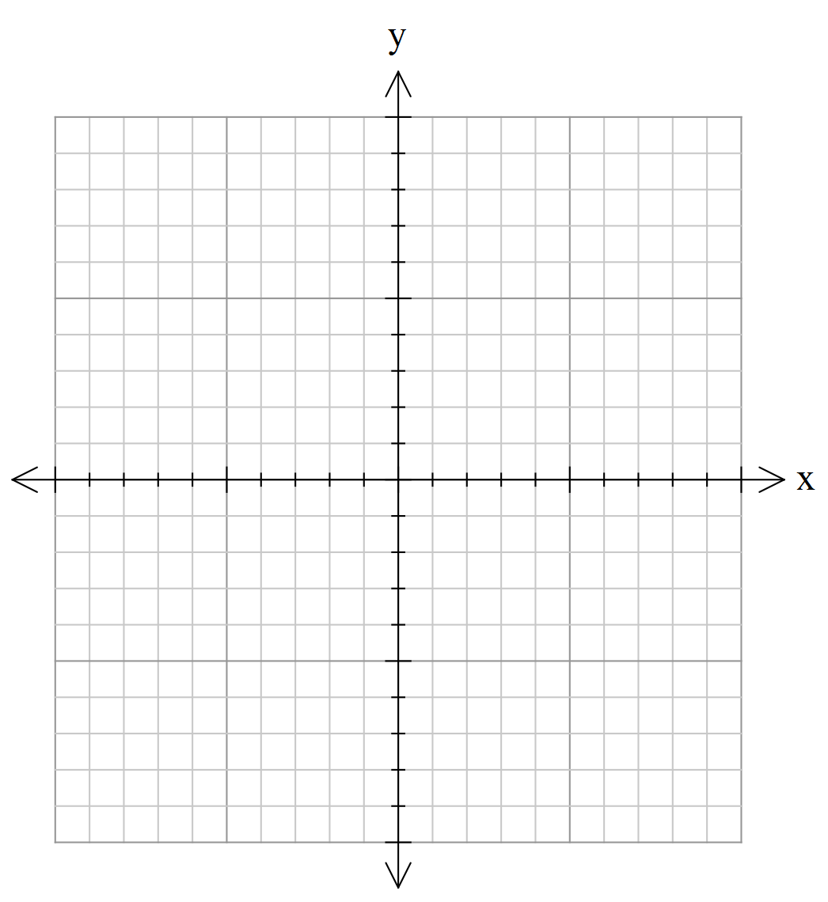

1. Describe the geometric relationship between the two graphs. (2 marks)

**Question 15 (14 marks)**

A particle P moves according to a variable position vector $p\left(t\right)=\cos\left(2t\right)i+sin\left(2t\right)j+2k$, where $0≤ t<2π.$

1. Describe the path of particle P. (3 marks)
2. Illustrate the path of the particle, showing the direction of motion, on the axes provided below. (2 marks)

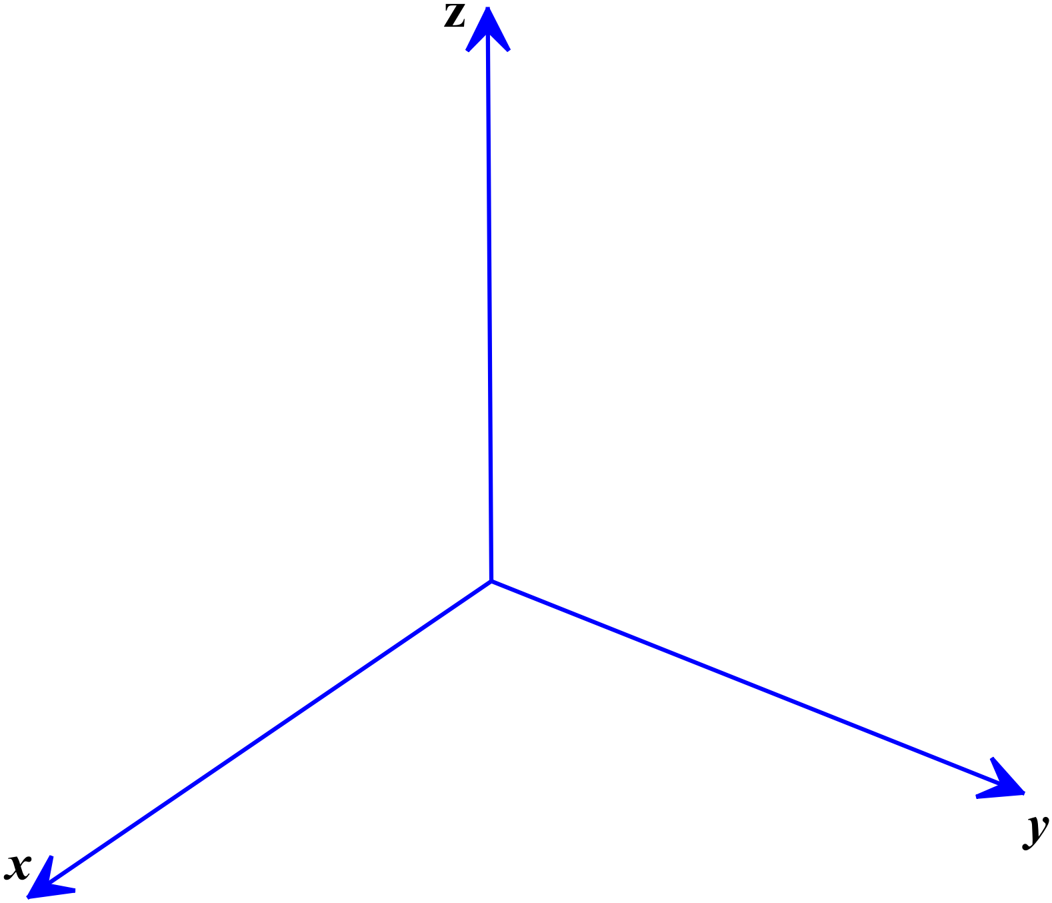

1. Determine the distance of particle P from the origin at time $t=λ$ and describe how this distance varies over time. (2 marks)
2. Determine the velocity  of the particle at any time $t$. (2 marks)

Another particle Q moves in a circle with centre (0,2,2) and radius 2 and keeps a constant distance from the -plane.

1. State the Cartesian equation of the circle of motion traced by particle Q. (2 marks)
2. Given the position vector of particle Q at time $t$ is given by

,

determine the distance between particles P and Q when $t=\frac{π}{2}$. (3 marks)

**Question 16 (9 marks)**

1. Use De Moivre’s theorem to establish the identity

 . (4 marks)

1. Determine the maximum and minimum values of



on the interval and the values of $x$ at these extremes.

(Hint: Let $x=\cos{θ}$ and use the identity in part (a).) (5 marks)

**Question 17 (6 marks)**

1. If  and, determine the functions  and  and state the domain and range of each. (4 marks)
2. For what value(s) does ? (2 marks)

**Question 18 (15 marks)**

Consider the rectangular prism sketched below.

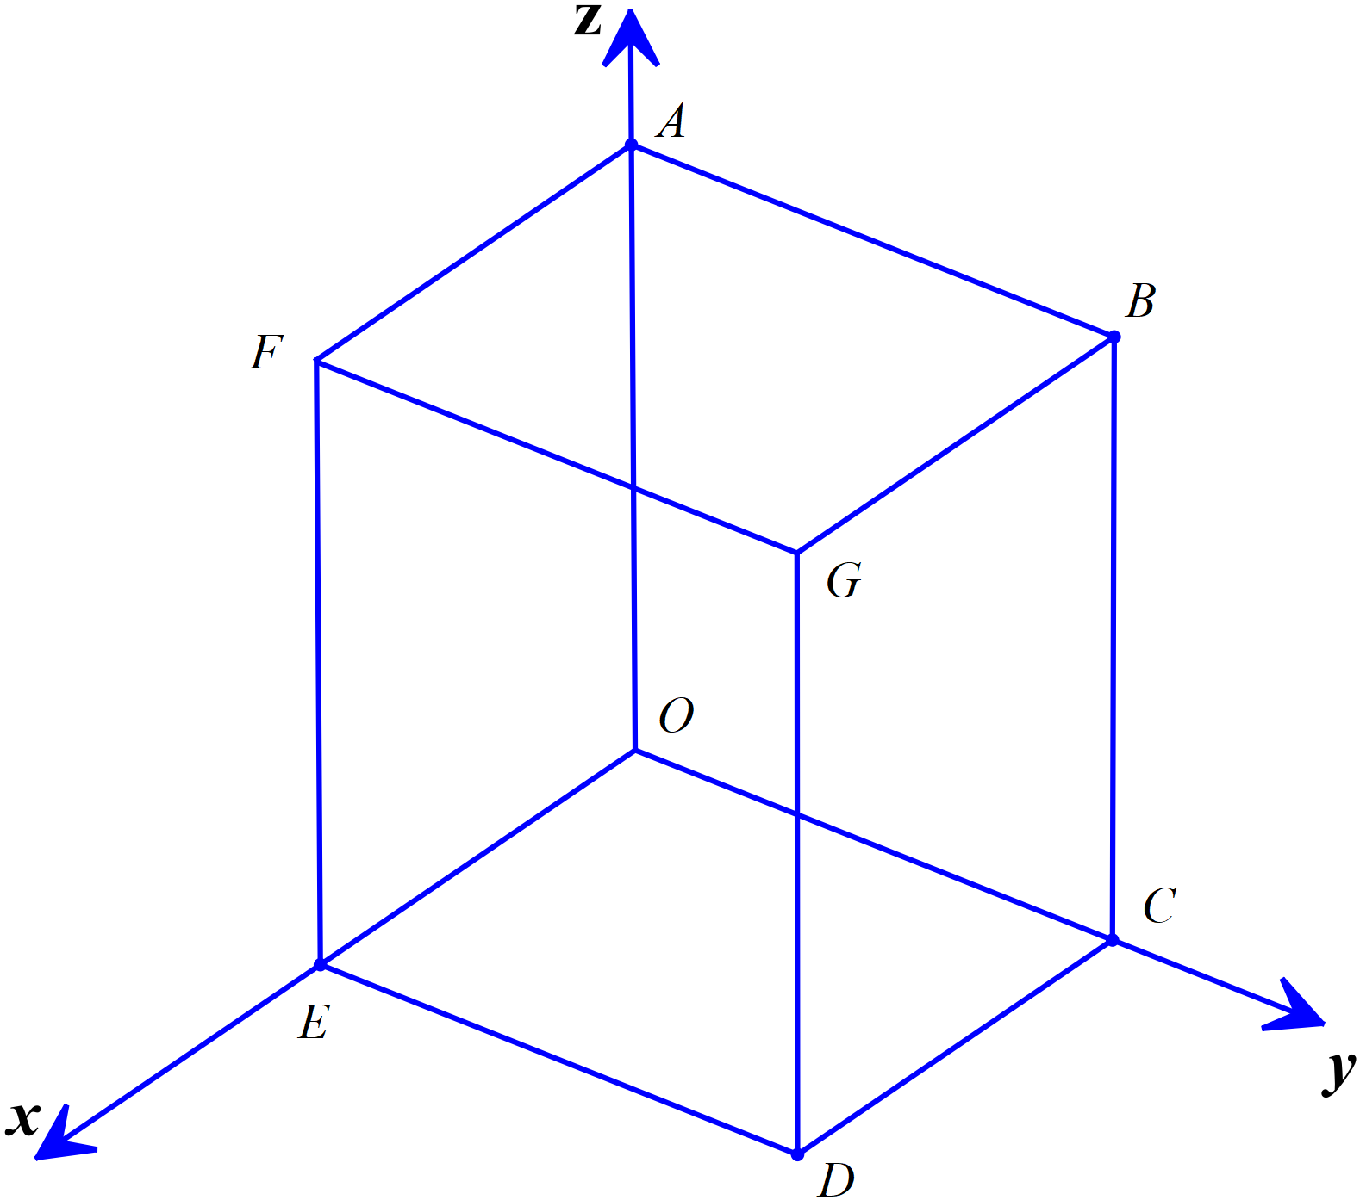

Let the position vector of G be **k** where  is some positive real number.

1. State the equation of the plane containing points DEFG. (1 mark)
2. The centre of a sphere is located equidistant from the vertices of the prism. Given that  determine the equation of the largest sphere that lies entirely inside the prism.

State its equation both in vector and in Cartesian forms. (3 marks)

1. Use a suitable cross product to determine the Carteisan equation of the plane containing the points O, B and G. (3 marks)

Let M be the mid-point of FE.

1. Determine, (5 marks)
2. the equation of the line L passing through M and C
3. the position vector of the point of intersection of the line L and the plane containing the points O, B and G..
4. If  determine the size of the acute angle formed by the line  and the plane containing the points O, B and G. (3 marks)

**Additional working space**

Question number: __________________

**Additional working space**

Question number: __________________

**Acknowledgements**

© MAWA, 2018

This examination is Copyright but may be freely used within the school that purchases this licence.

* The items that are contained in this examination are to be used solely in the school for which they are purchased.
* They are not to be shared in any manner with a school which has not purchased their own licence.
* The items and the solutions/marking keys are to be kept confidentially and not copied or made available to anyone who is not a teacher at the school. Teachers may give feedback to students in the form of showing them how the work is marked but students are not to retain a copy of the paper or the marking guide until the agreed release date stipulated in the purchasing agreement/licence.

*Published by The Mathematical Association of WA*

*12 Cobbler Place, MIRRABOOKA 6061*